Swiss Day at Fudan University 复旦大学瑞士日
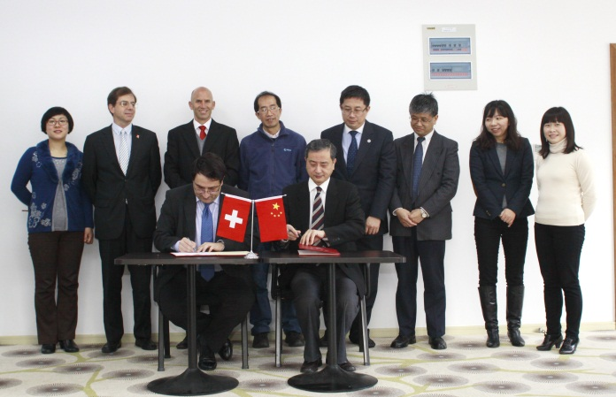
Vice President of EPFL visited Fudan and renewed the MoU (January 2013)
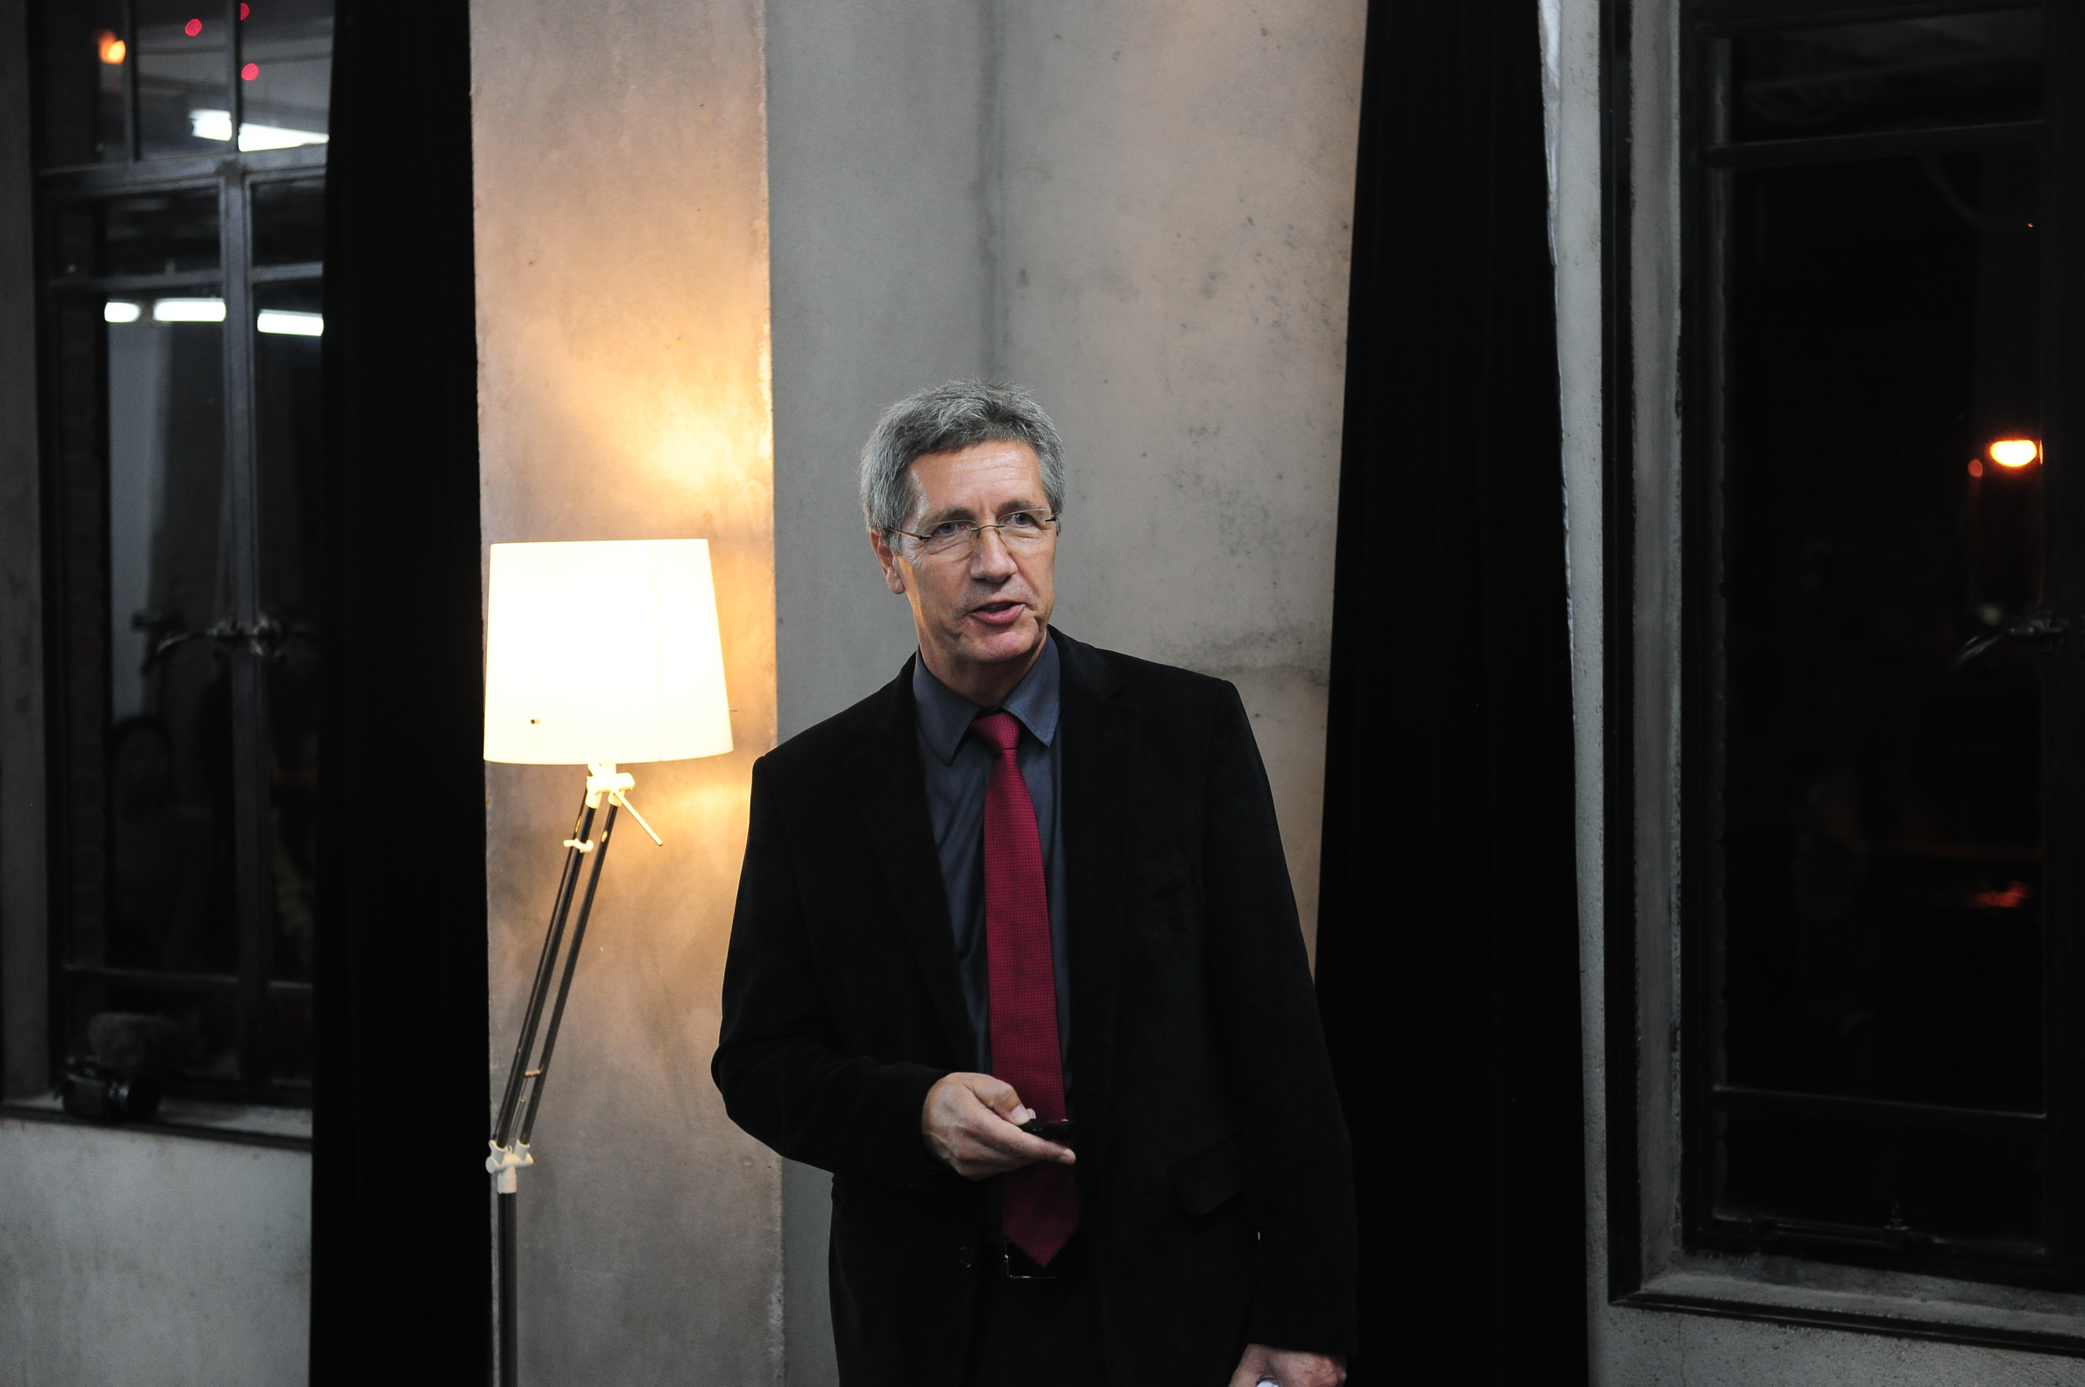
Prof. Thomas Grunwald from the Swiss Epilepsy Centre in Zurich who delivered a lecture at the Medical School, Fudan, (May 2013)
Program 议程
Date: June 16 2014, 9:30am-13:30pm
Venue: Fudan Foreign Afairs Office House, Fudan University,
Handan Road 220, Shanghai, China
(上海市邯郸路220号复旦大学校内外事办公室大楼)
Rundown:
- 9:30-10:00 registration
- 10:00-10:10 Welcome speech by Mr. ZHU Chouwen,
Dean of Fudan University Foreign Affairs Office
- 10:10-10:20 Welcome speech by Mr. Heinrich Schellenberg
- Consul General of Switzerland in Shanghai
- 10:20-10:30 《Swiss Higher Education and Technology
Diplomacy》 by Mr. Pascal Marmier, swissnex China CEO
- 10:30- 11:30 Lecture by Prof. Thierry Courvoisier
President of Swiss Academy of Sciences and Arts
- 11:30- 12:30 University Time
(every 15 minutes in Lecture Room)
Info session by EPFL
info session by EHL
info session by HEC Lausanne
Info session by IHEID
- 12:00-14:00 Swiss Apéro and networking with Alumni
(in the lobby of the FAO house)
Goals:
- Promote the excellence of Swiss higher education and
research
- Provide a platform for Swiss universities
- Provide a platform for students/alumni meeting
swissnex China holds a series of Swiss Day events at different universities in Shanghai and Beijing. The purpose is to promote Swiss higher education, research and innovation to the students and faculties from first-class Chinese universities, while providing a platform for Swiss universities to present themselves and the Chinese alumni community of Swiss universities to exchange.
Fudan is an excellent university in both social science and natural sciences in comprehensive fields and thus one of the most interesting sources of potential students to fill various levels of study positions in Switzerland. Fudan University is a key partner of University of Zurich in China, and it is also a supportive partner for the SSSTC program in Neuroscience and Medical Technology. EPFL and Fudan also signed MoU early in 2007, and in January 2013, the vice president of EPFL paid his official visit to Fudan and renewed the MoU.
As it is the first Swiss Day in Fudan University, the highlight of the event could be a session of two presentations: a speech from the CEO swisssnex China/ Vice Consul General of Switzerland in Shanghai, Mr. Pascal Marmier and a lecture from Prof. Thierry Courvoisier, astrophysicist at University of Geneva and President of the Swiss Academy of Sciences and Arts. Mr. Heinrich Schellenberg, Consul General of Switzerland in Shanghai will also deliver welcome greetings to the event. Over noon time, a “Swiss Apéro” will be followed. There are also some booths displaying Swiss universities, research institutions and organizations during the whole event. Some smaller speeches by alumni or students will be held and there will be interaction with the visitors via swissnex SNS such as Weibo and Wechat.

