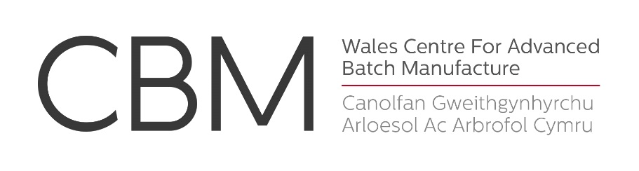
Fully-Funded PhD Studentships
Qualification type:PhD
Location: Swansea
Funding amount: £14,057 per annum (2015/16 subject to 1% increase p.a.)for 3 years, plus £5,000 Research Development Grant.
Hours: Full Time
Placed on: *****
Closes: First deadline 26 February 2016
Wales Centre for Advanced Batch Manufacture (CBM)
CBMis an excitingnew initiative that has been jointly established by the University of Wales and University of Wales: Trinity Saint David. CBM is a manufacturing and research facilitycentred on the creative application of advanced technologies and techniques across a wide range of manufacturing sectors including aerospace, medical engineering and craft sectors. PhD students will have access to CBM’s full technology platform, including computer-aided design, 3D scanning technologies and layer-additive manufacturing technology,for exampleElectron Beam Melting.
For more information on CBM see: www.cbmwales.co.uk
Fully-Funded PhD Studentships
CBM is offeringfully-funded PhD studentships to undertake applied research in the following areas:
- Finite Element Analysis for the validation of next-generation additive-manufactured products;
- Design optimisation of medical products using 3D scanning technology;
- Application of Advanced Manufacturing Technologies to the craft sector;
- Development of Electron Beam Melting technology for safety-critical aerospace components;
- Evaluation of advanced materials for additive-manufactured medical implants
For further details on each project see: www.cbmwales.co.uk/research-news
As part of the above research projects, candidates will have opportunities to undertake research and advanced training at a number of partner institutions, organisations and companies, in the UK, Europe and beyond.
Candidate requirements: Minimum of 2:1-level degree in a relevant discipline
Candidates must demonstrate an interest in thecommercial application of research.
Funding: Home/EU: Full payment of tuition fees and maintenance stipend of £14,057 per annum. Studentship covers full UK/EU (EU applicants who have been resident in the UK for 3 years prior to application) PhD tuition fees and a tax-free stipend at the current RCUK rate (£14,057 in 2015/16).
A Research Development Grant of £5000 is also available for each candidate to support advanced research training for the duration of the studentship.
How to Apply
Deadline: First deadline for applications 26 February 2016
Candidates are asked to complete and return the application form availablefrom:
www.wales.ac.uk/en/AboutUs/Vacancies/Vacancies.aspx
Completed applications should be returned to the address specified on the application form.
Candidates are strongly advised to contact CBM for an informal discussion before applying.
Contacts: For general enquiries, please email: Dr Neil Strevett
Email: Neil.Strevett@wales.ac.uk
TEL: 02920 375053/ 07534 228760



